The summer meeting for District Rocky Mountain was held at the Wild Mountain Smokehouse and Brewery, Nederland, CO on August 19. This was one of the furthest meetings from the I25 Font Range corridor for the District (about a two-hour bus ride from Fort Collins). It certainly was quite a scenic jaunt up Boulder Canyon to the destination.

After the beer tasting / social ‘hour’, President Jeff Biegert, New Belgium Brewing Co., and Technical Chairman Finn Knudsen, EBCI, heartily welcomed the meeting participants. (See accompanying Photo 1). Finn then introduced the ‘guest speaker’, the host of the evening, Tom Boogaard. Tom’s self-described working job title and moniker: Owner/Brewer/Cook/Reluctant Plumber and Electrician of the ‘Wild Mountain Smokehouse and Brewery’. The title of Tom’s talk: Madness, Hubris, or Sheer Genius? The Joys of Growing a Brewpub from Raw Land. Tom’s detailed and compelling talk was full of real-life information of his journey mixed with nicely crafted, humorous stories and anecdotes. (See accompanying Photo 2).

The following is an excerpt from Tom’s ‘Abstract’ of his technical presentation.

‘In 2004, husband & wife Tom & Cori Boogaard, disillusioned with careers in Sales & Marketing & IT respectively, decided that their hometown of Nederland Colorado would be the perfect place for a spanking new building housing a brewery & barbeque-themed brewpub. The couple opened the doors to their creation in early March of 2007. Wild Mountain was able to purchase a ‘turnkey’ used, electric-fired three Barrel Pub Brewing system and all fittings, three fermenters, four single walled serving tanks, and a glycol chiller. Tom squeezes three & a half barrels of wort into the kettle & brews twice a day to yield about seven barrels of wort into the fermenter. The brewery has been limited to producing ale styles, which are not filtered & only kegged by special request. The bar offers four of Wild Mountain’s ales on tap at all times as well as four “guest taps”. Tom is responsible for most of the recipes, the menu layout & content, which truly has something for everyone with an emphasis on slow cooked smoked meats and house made sauces’.

Following the presentation, Tom led a tour of the brewing operations. Participants were very impressed by the compact layout and design of his system. They appreciated his ‘hands-on’
comments and approach to how he brought the concept of the brewery to fruition. (See accompanying Photo 3).

President Jeff Biegert and Technical Chairman Finn Knudsen took the opportunity to salute Tom for a great presentation. (See accompanying photo 4).

President Biegert opened the business portion of the evening by welcoming the attendees and thanking Tom and Cori and their staff again for hosting and sponsoring the summer meeting. Membership chairman Dana Johnson, Birko Corporation, reported that current membership is approximately 176; this number is up slightly from the previously reported count of 168 at the spring meeting. Dana encouraged all new attendees to become MBAA members. The attendance for the meeting was approximately 56; a mixture of professional and associate members and their guests. Secretary Jon Kemp, ABInBev, reporting for Treasurer Dan Overmyer (who could not attend) stated that the District is financially sound, with ample cash reserves. Jeff Biegert made a nomination for a new Publicity Chairman, Jim Canary ABInBev (ret). The nomination was seconded, voted on and passed.

As customary, the evening concluded with a very lively raffle of prizes supplied by Wild Mountain Smokehouse and Brewery. A colorful and festive collection of mugs, hats, shirts and gift certificates were raffled off to the appreciative crowd.

A final note of business to mention: The next function sponsored by District Rocky Mountain is the Technical Out-of-Towner, to be held in Grand Junction, Colorado September 18-20. The dates coincide with the annual Grand Junction/Palisades Wine Festival.

James (Jim) Canary
Publicity Chairman & Past Treasurer
Master Brewers Association of the Americas District Rocky Mountain
August 23, 2009

Accompanying photos:
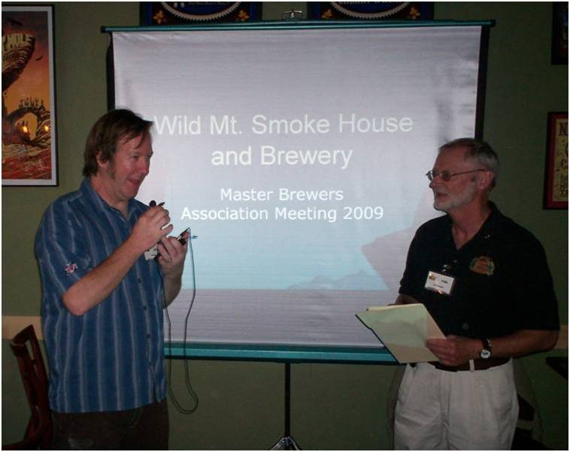

Photo 1: Jeff Biegert and Finn Knudsen Welcome MBAA District Rocky Mountain.
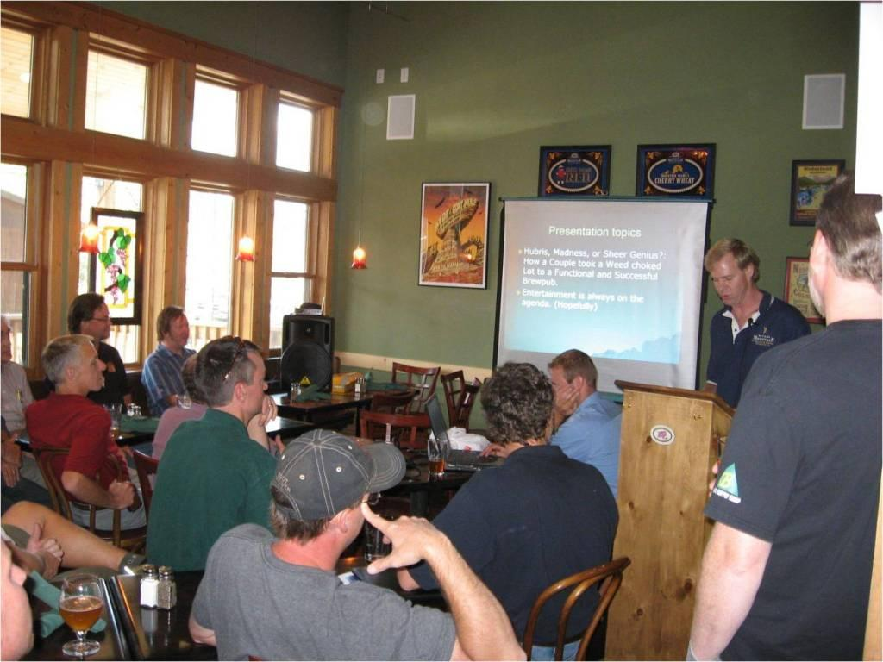

Photo 2: Tom Boogaard’s Presentation to the Attendees.

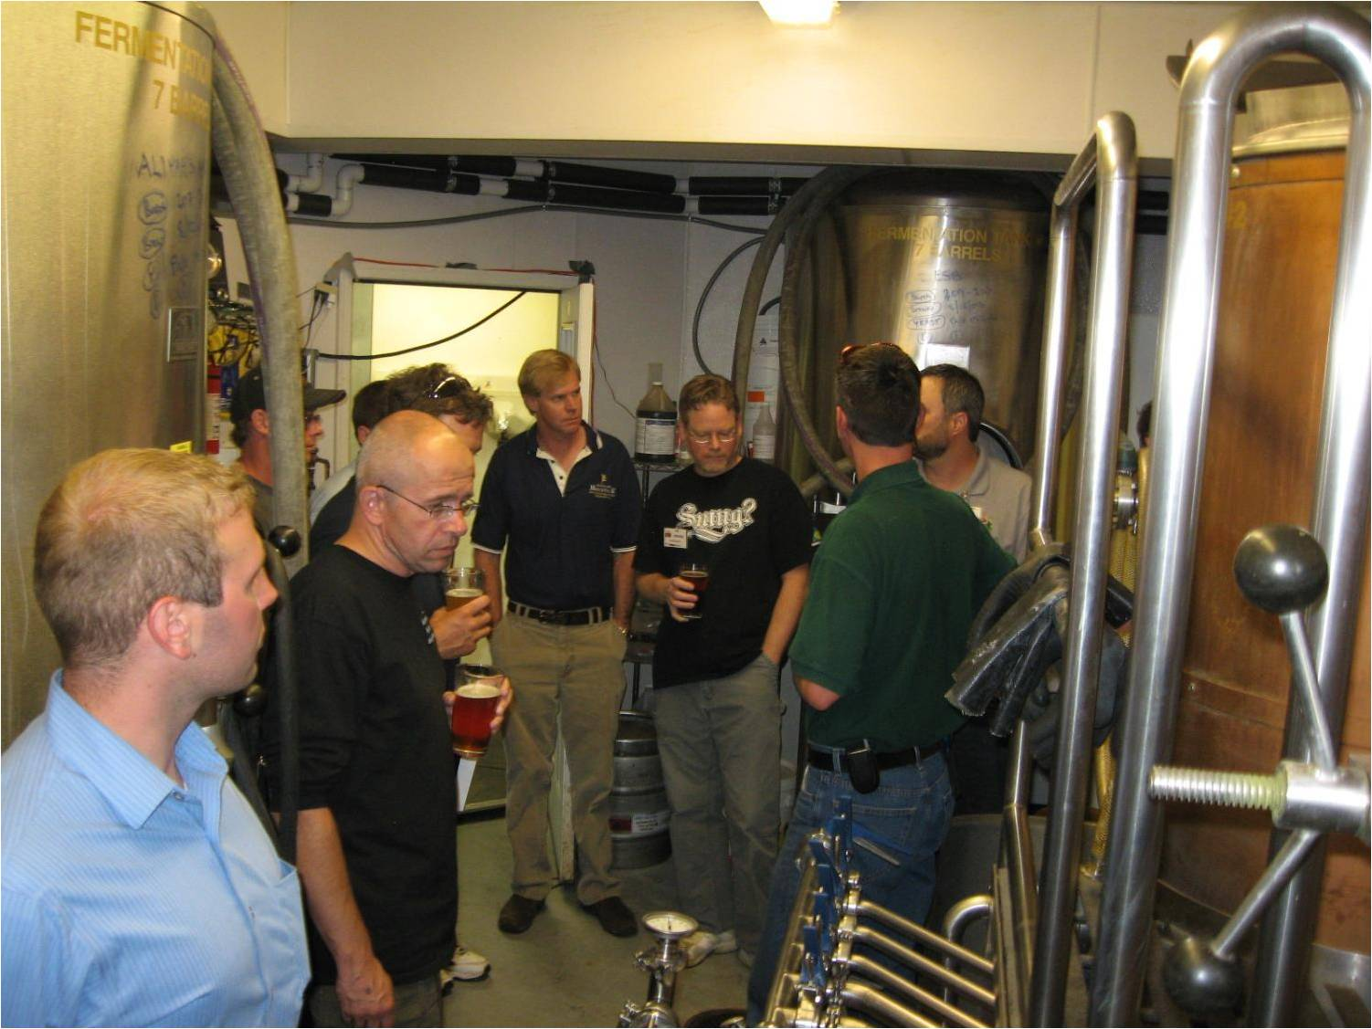

Photo 3: Tom leads tour of brewery
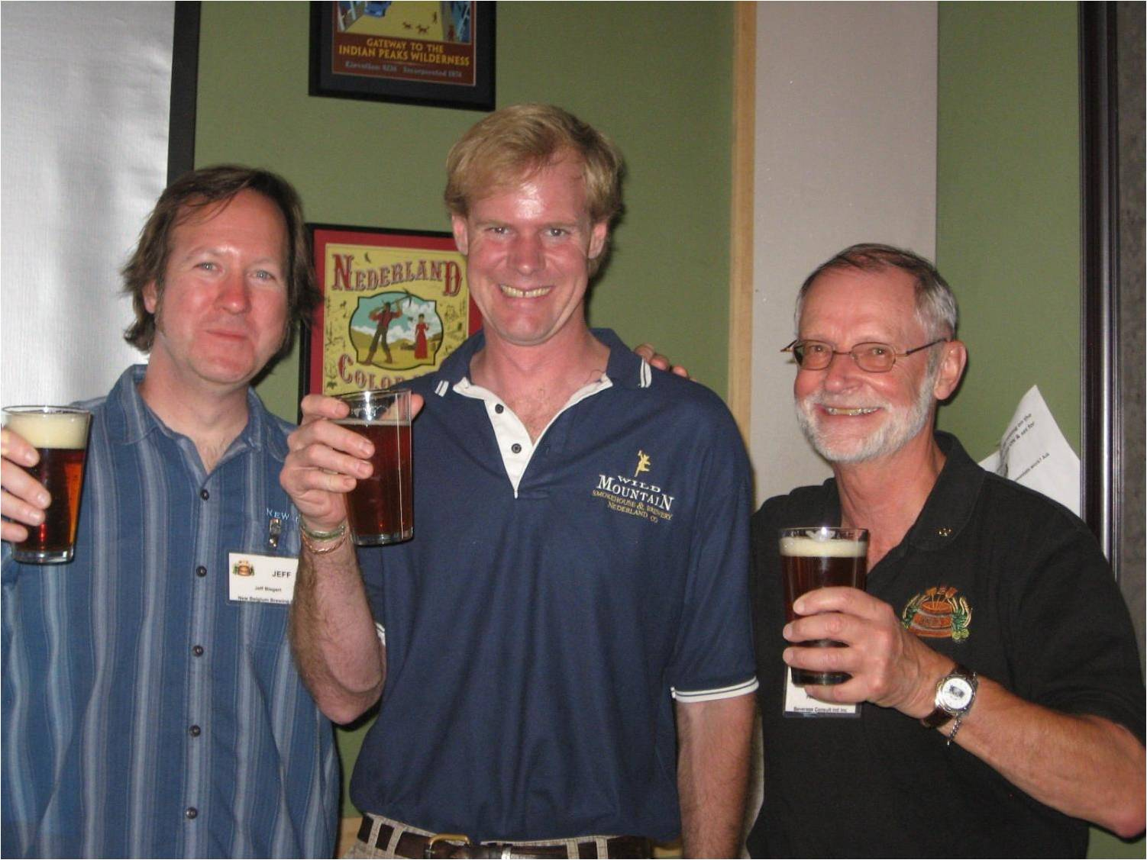

Photo 4: President Jeff Biegert and Technical Chairman Finn Knudsen salute owner
Tom Boogaard for a great presentation.

